CSS GRID

{

display: grid

}

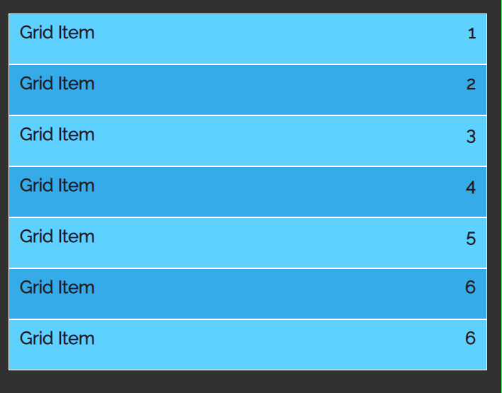

*/* 200 px columns on left and 100px column on right */*

grid-template-columns: 200px 100px;

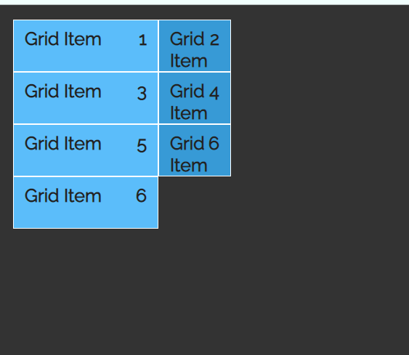

*/* to flexibility, 2fr means twice the size of column and 1fr */*

grid-template-columns: 2fr 1fr;

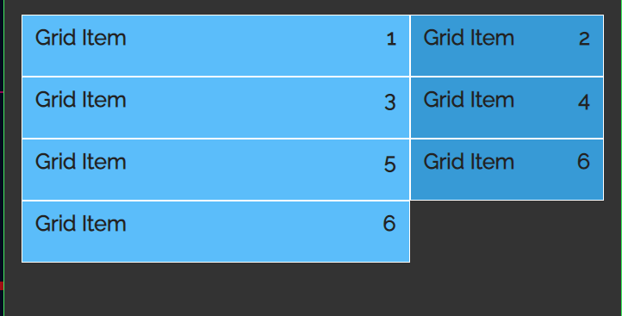

*/* repeating columns size 4 times of 100px */*

grid-template-columns: repeat(4, 100px);

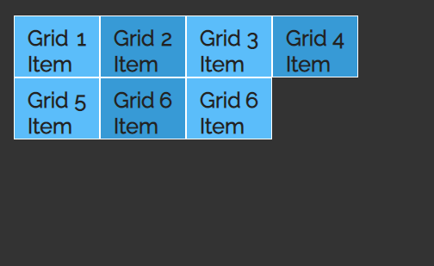

*/* the first rows will be in size 200 px and 2nd row will be in 150px */*

grid-template-rows: 200px 150px ;

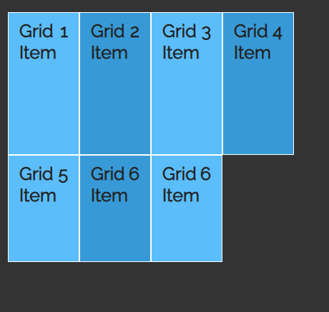

*/* grid auto row- it will automatically resize the rows to the given values*/*

grid-auto-rows: 250px;

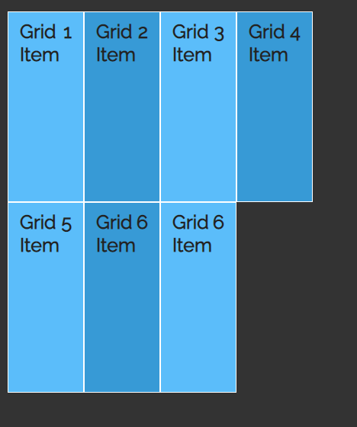

*/* If we give the size of first column as 300px, the other rows are still 250px (as mentioned in grid-auto-row) */*

grid-template-rows: 300px;

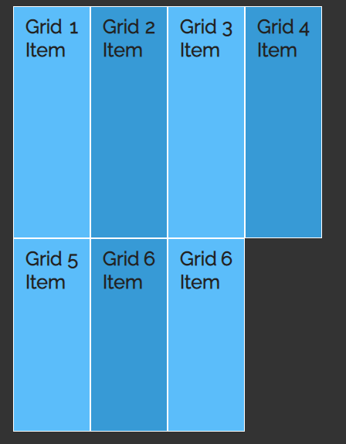

*/* to size the rows according to the content */*

*/* It indicates the minimun height of the row will be 150px and maximum height will be auto, to the content display */*

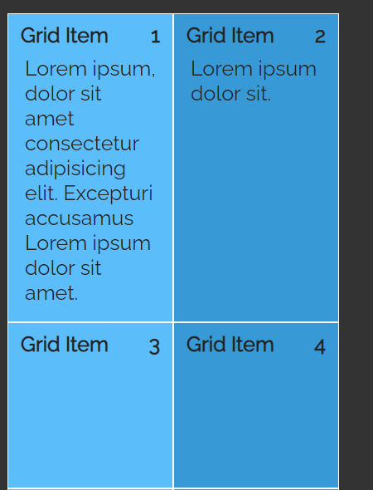

*/* Instead using row-start and row-end , we can use span , similarly ro column-start and column-end */*

.grid-item-4{

grid-row: span 2;

}

.grid-item-5{

grid-row: span 2;

}

**MDN link to learn CSS Grid :**

[*Basic Concepts of grid layout - CSS: Cascading Style Sheets | MDN*](https://developer.mozilla.org/en-US/docs/Web/CSS/CSS_Grid_Layout/Basic_Concepts_of_Grid_Layout)